Getting started with Azure virtual desktop

Create a security group in m365 admin center under teams & groups ? active teams & groups > security groups > add a security group
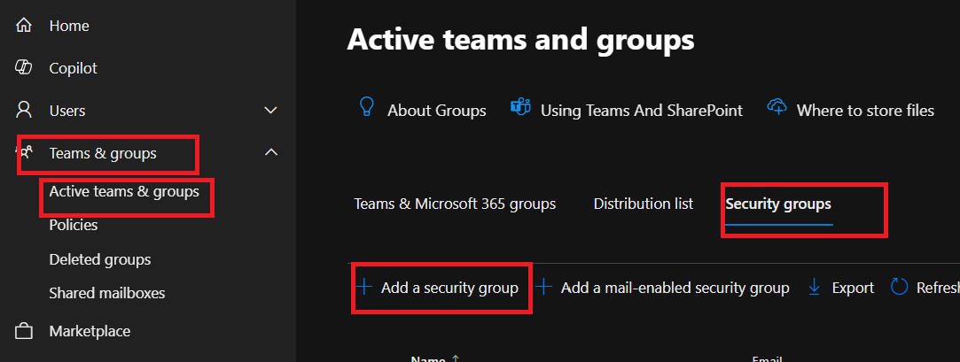
Give a name for your security group. For this group we indicate as Virtual Desktop users. Click next then create group.
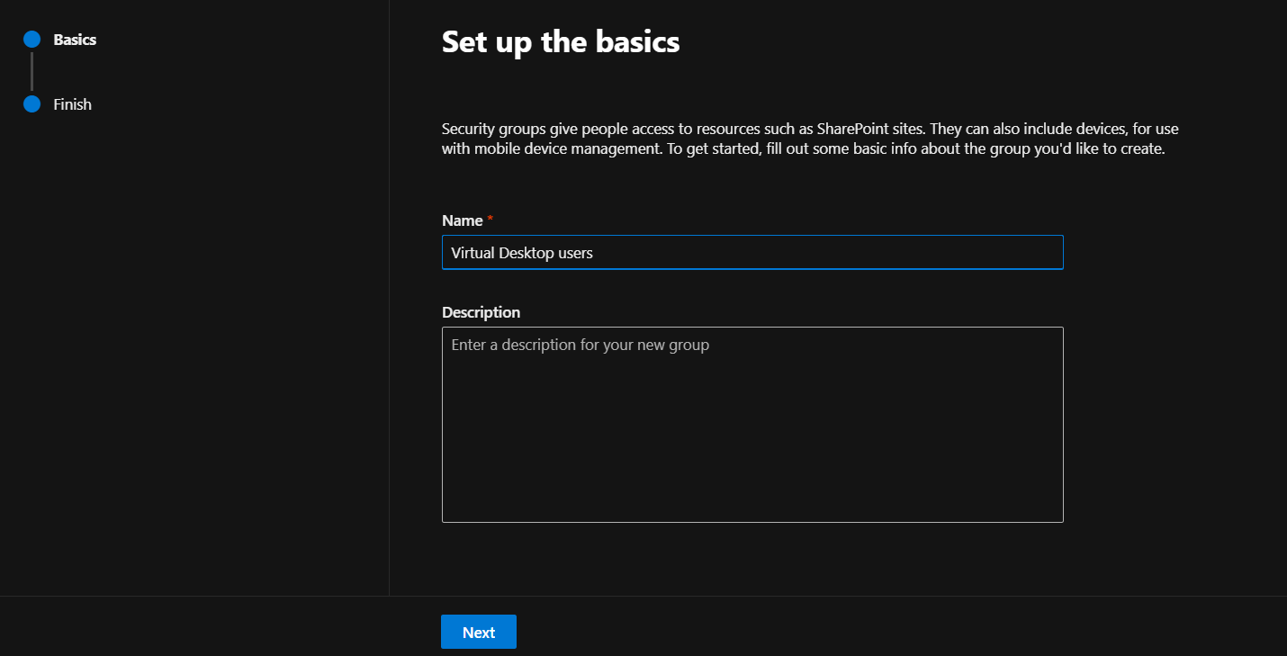
Create another one for virtual desktop admin
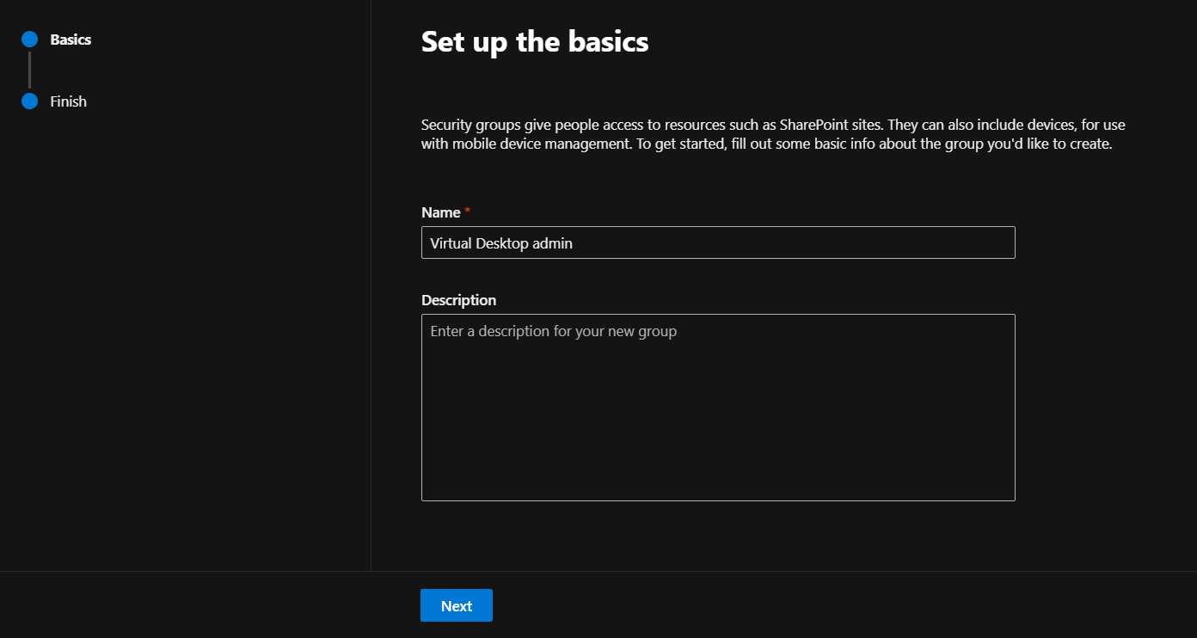
Click on The Virtual Desktop users then members then view all and manage members
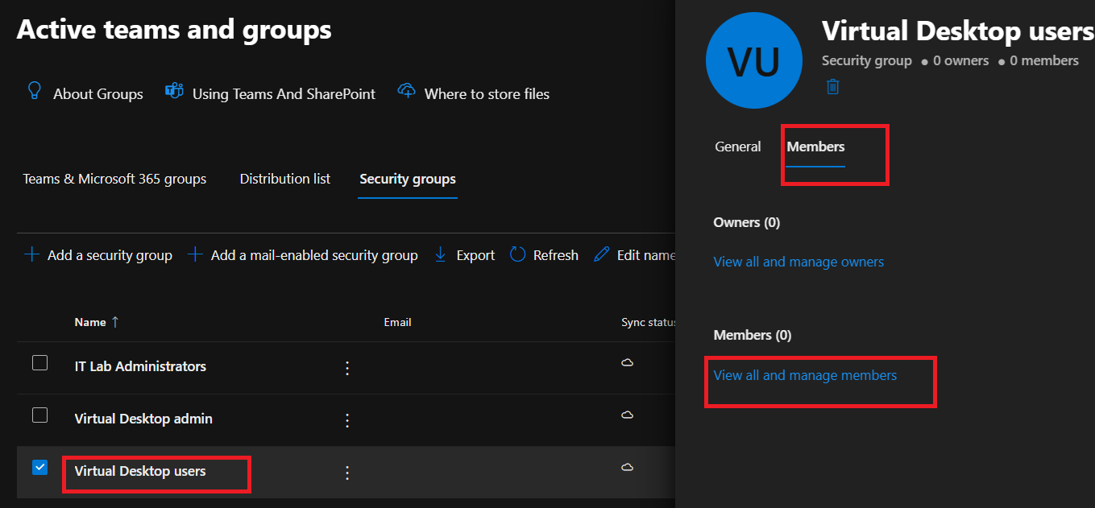
Add member
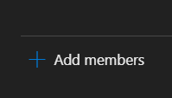
Select the member you want to add
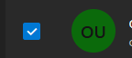
Click on Add
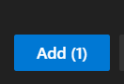
Do the same for your Virtual desktop admin group where you assign an account to be the virtual desktop admin to install apps etc.
Head to resource group and create a resource group. For now we use East US region. Click on review + create and create.
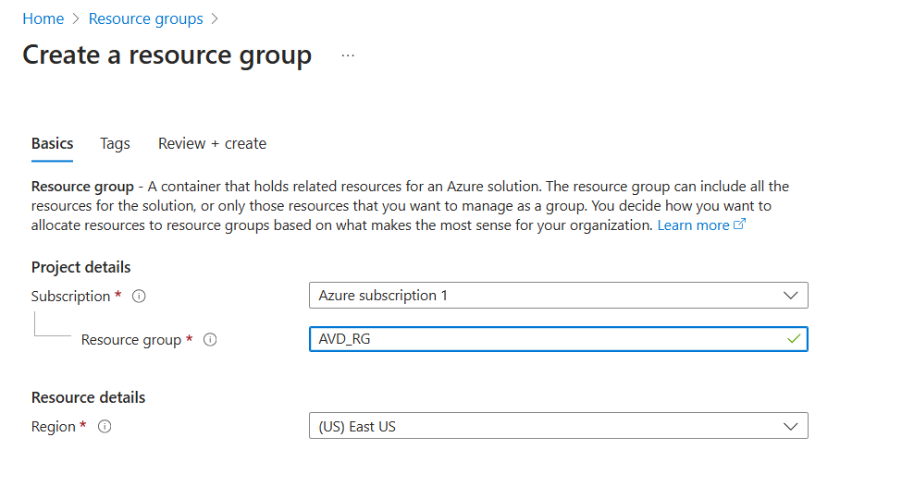
Now search for virtual network and create
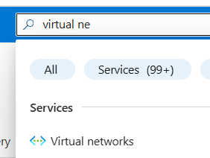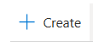
Give it a name and click on next
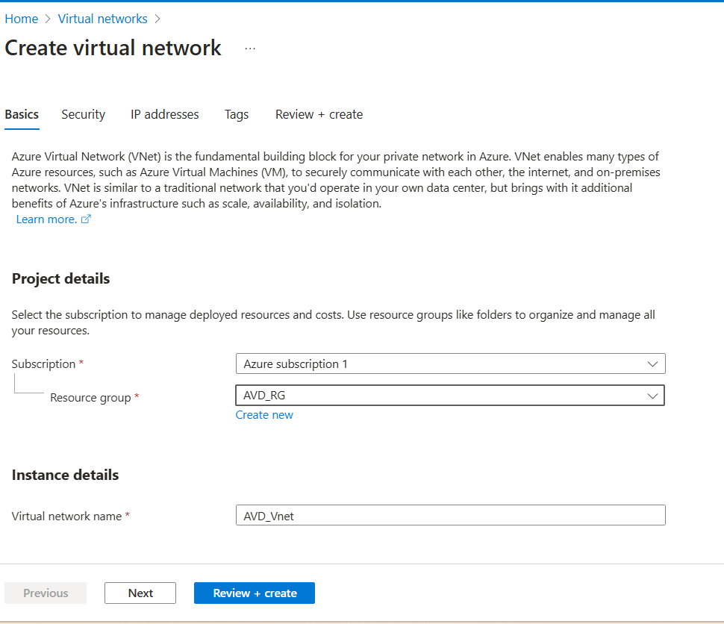
For now we can leave it as default for security settings. Click on next
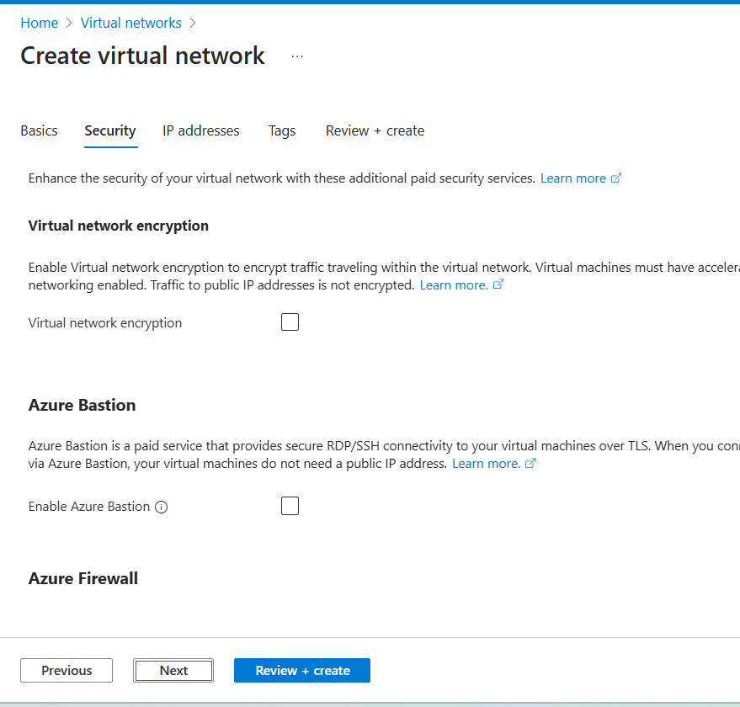

We can leave it as default as there are a lot of IP addresses available. Click on next
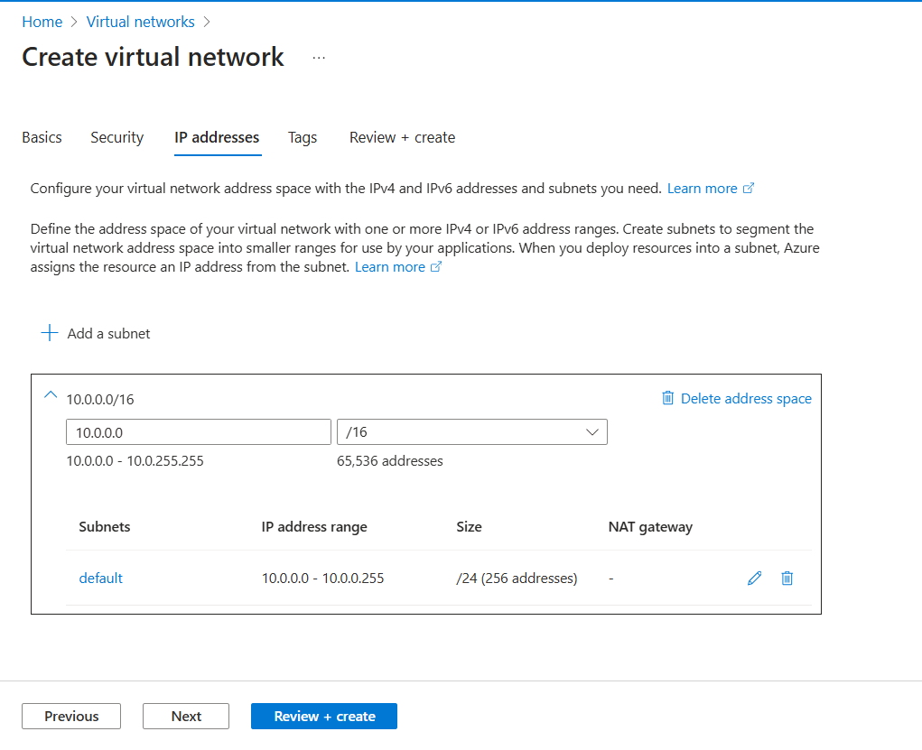
For tags we also leave it as blank and click on next then click on create
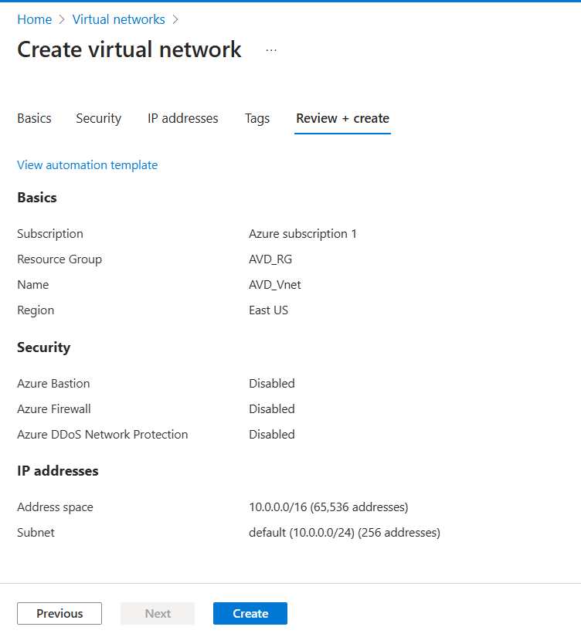

Once done we can head on to Azure virtual desktop. We will need:
- Host pool : this is where your virtual desktops run.
- Application groups: manage what apps users can access
- Workspaces: Provides the user interface for users to access resources
Look for Virtual desktop
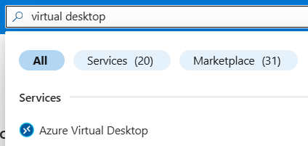

Create a host pool
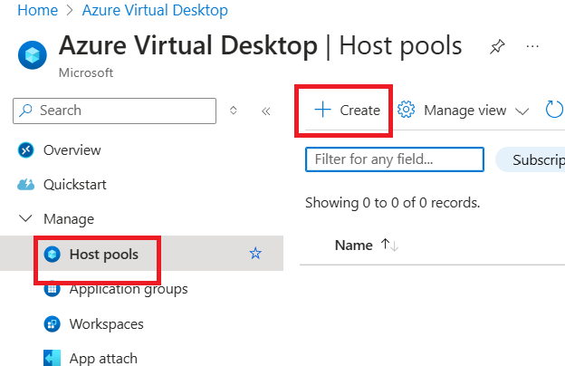

Select the resource group you created earlier and assign a name for the host pool. Select Desktop for app group type for the full desktop experience.
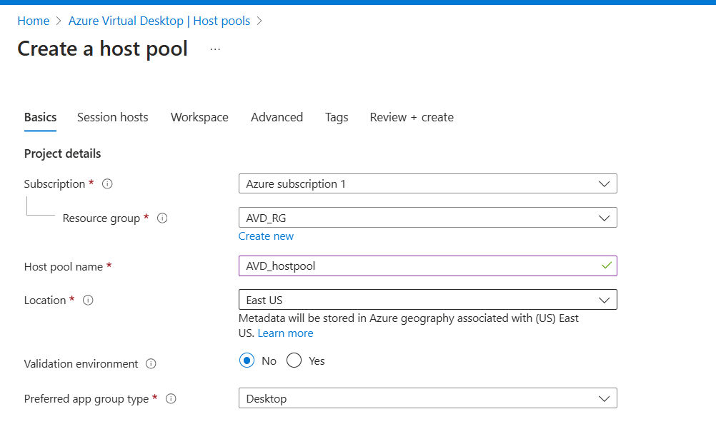

Select the following:

Host pool type: Pooled (means multiple users share same VM resource rather than having dedicated machines, unless there are users who require special apps)
Session host config: select no as we want to configure the later steps. yes for a more hands-off approach and let Microsoft handle the updates and maintenance.
Load balancing: Depth-first. Fills up 1 vm to max before moving on to the next. This way we maximise VM usage. Breadth first is the other option which spreads users evenly across VMs but although there is better performance there will be higher costs involved.
Max session limit: can start with 5 to 10 for small office and adjust based on patterns.
Click on next after that
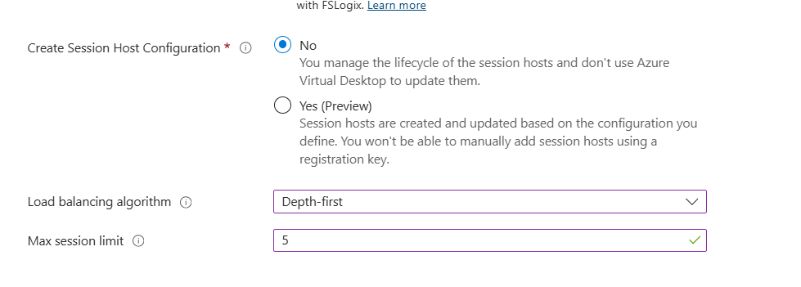
Select yes to add virtual machines
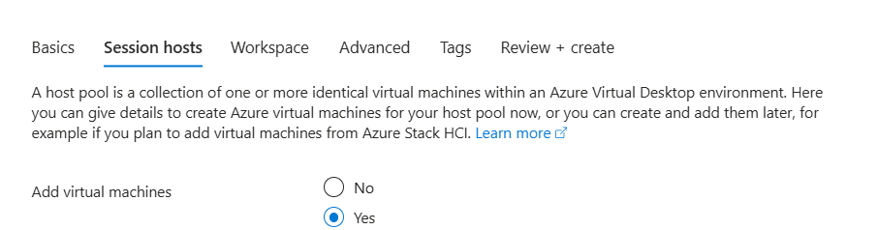

Choose the resource group you created
Name prefix: can indicate as per your preference. E.g. if name prefix is testcorp then first and second VMs are called TestCorp-1, TestCorp-2 etc.
VM location: choose same region
Availability options: as we are not deploying on corporate environment we can select no infra redundancy required but by selecting across different zones you can ensure that in case 1 DC (datacenter) fails your AVD (azure virtual desktop) is still working.
Security type, secure boot and TPM can leave as is.
Image: can choose based on your preference.
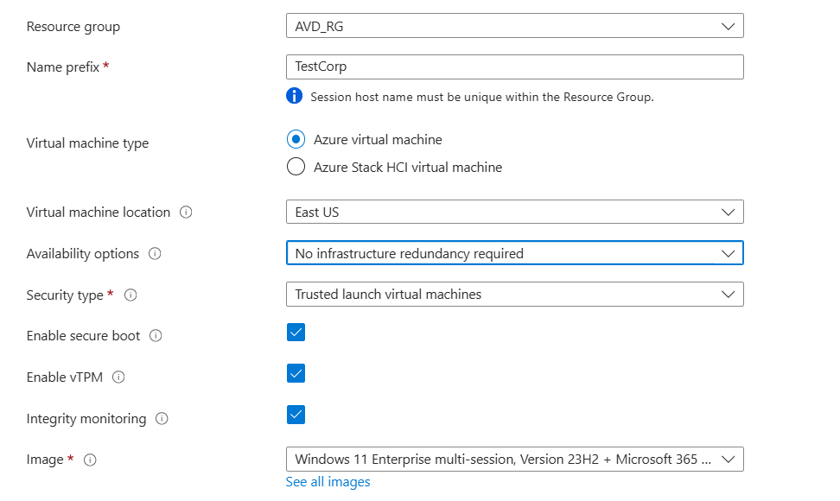

For the VM size we can change to a cheaper version that the default selected of D2as to save cost. Of course we will further optimize cost by automating it to power up only during business hours. 4GB RAM is tight but workable.
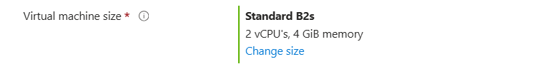
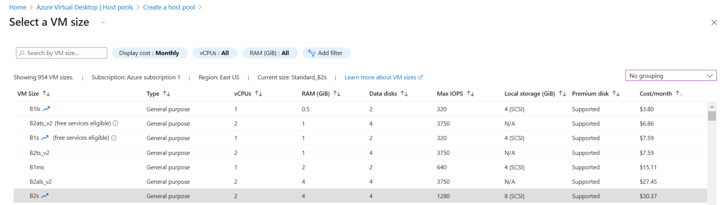

For number of VMs we keep as 1 first as a test. OS disk type standard SSD as HDD is too slow and default we keep to the minimum 128GB.
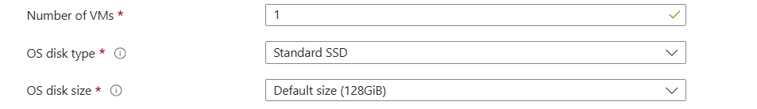
Boot diagnostics can leave as default
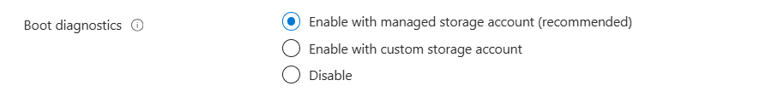

For network, select the vnet you created earlier.
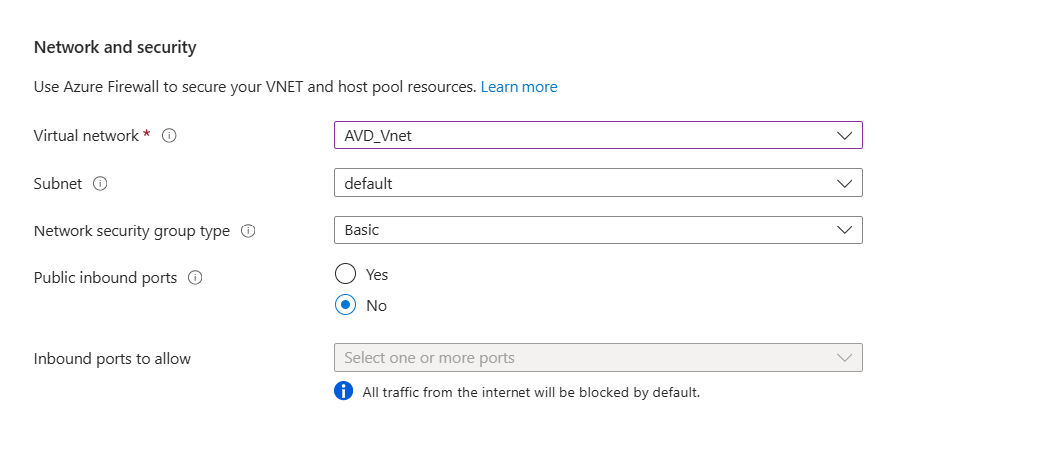

Next select Microsoft Entra ID for which domain to join and select yes for intune.
Create a username and password for the VM admin account
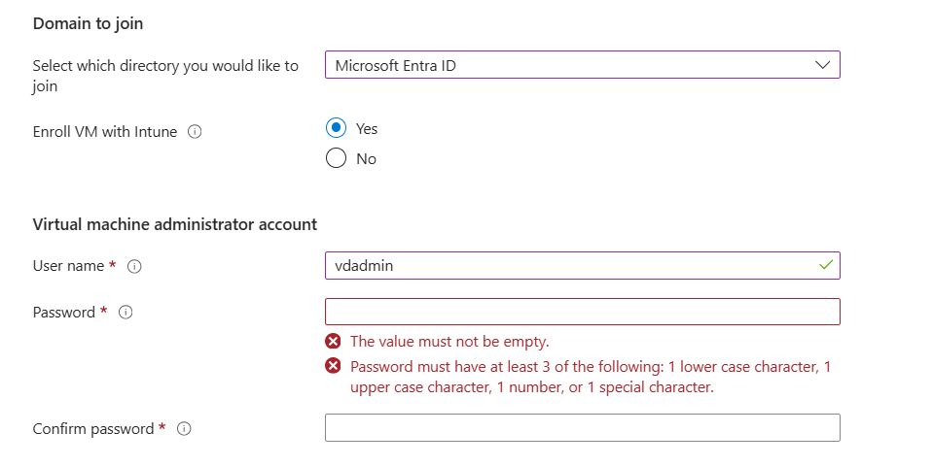
This can leave as is and click on next
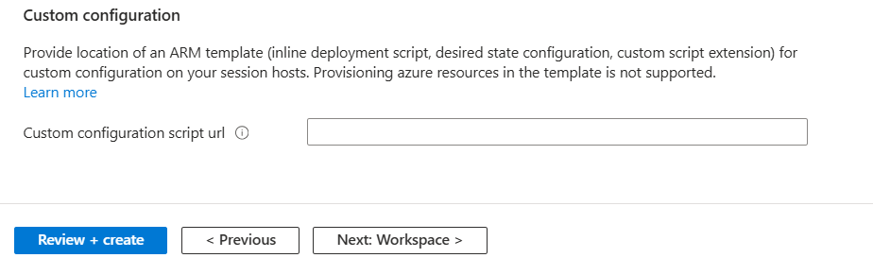
We can leave workspace as no first as we are doing it a bit later. Click on Review + Create and then create. It will take about some time to create this.
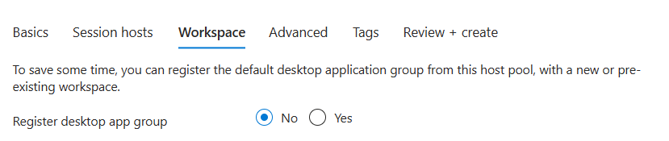
Once done, they will create a hostpool as well as an application group
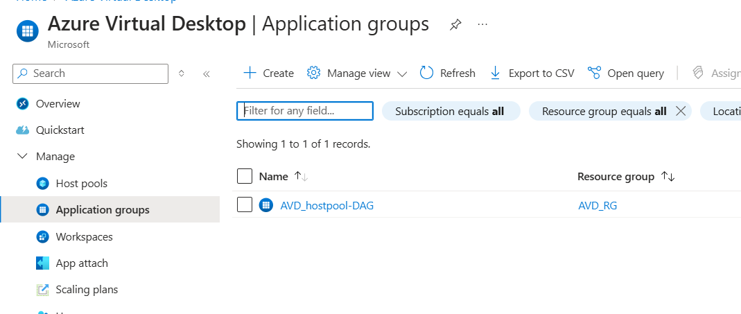
Now, we can proceed to create a workspace
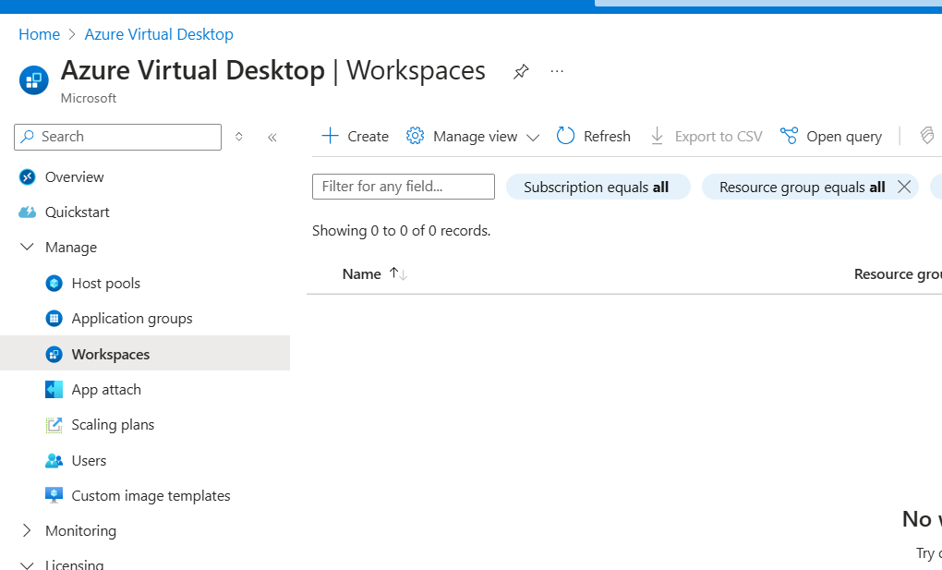

Choose your resource group and assign a workspace name
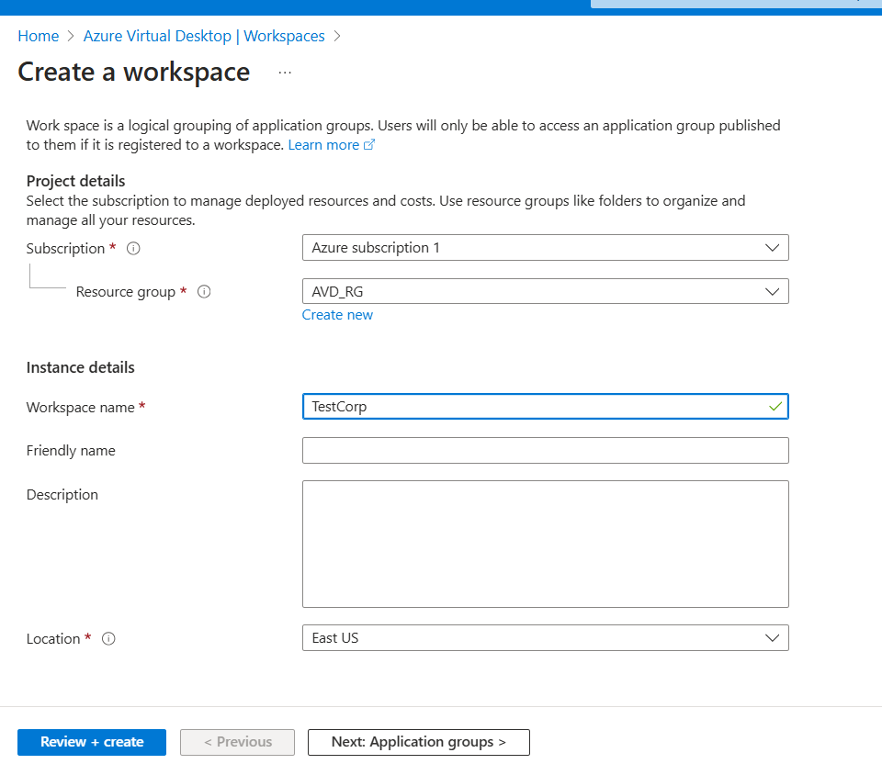
Click on “Yes” then register application groups and then select the app group created in the previous steps. The Review + create then create
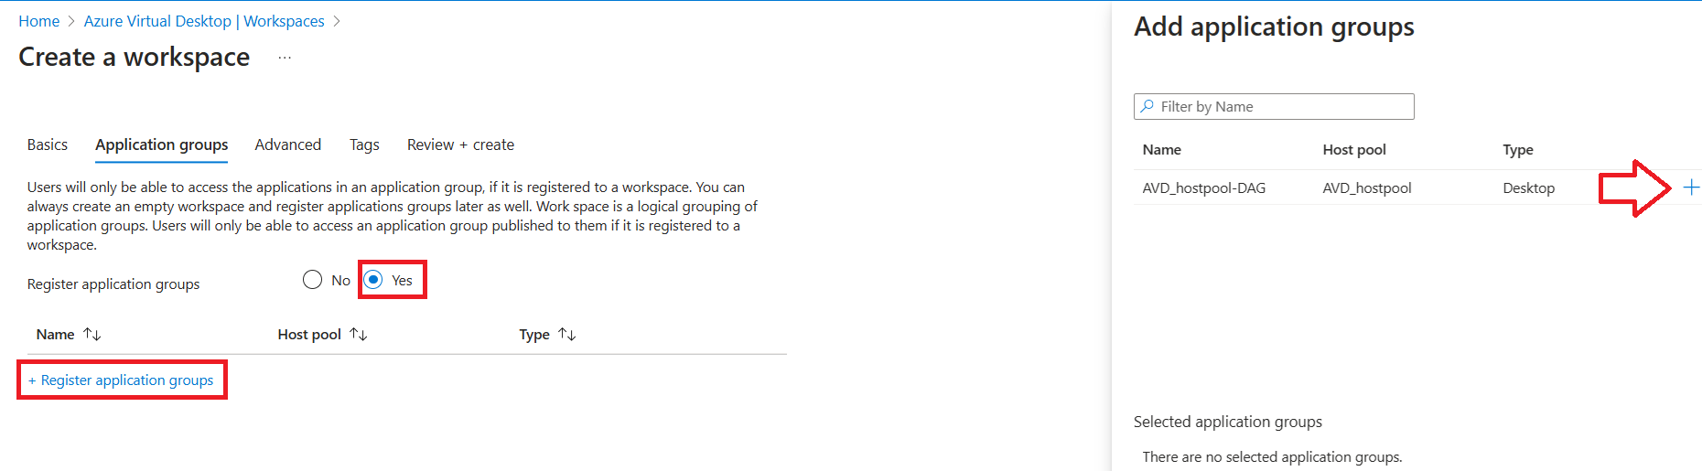
Go back to your application group in your host pool
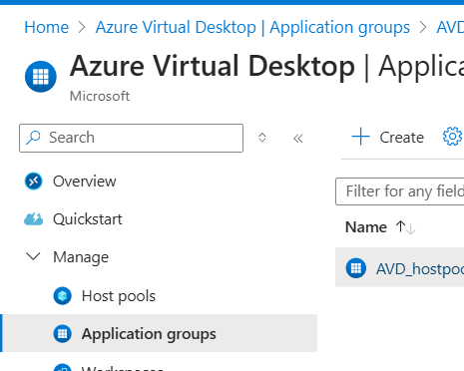

Click on Assignments then Add
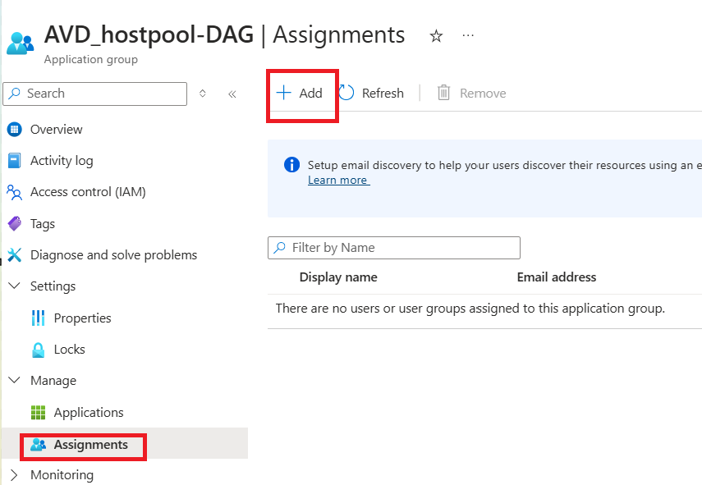

Add the 2 groups you created earlier in M365 admin center
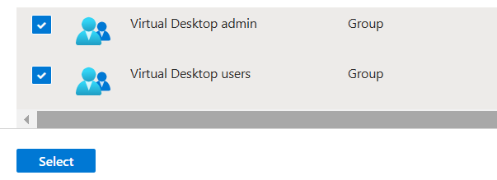
Go back to your resource group and select IAM > Add role assignment
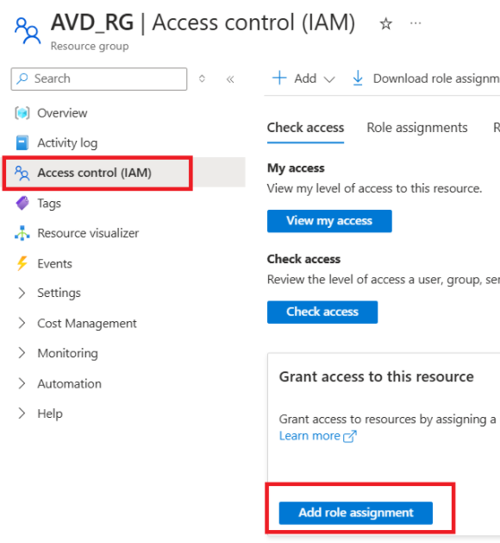

Search for and select virtual machine user login and click on next
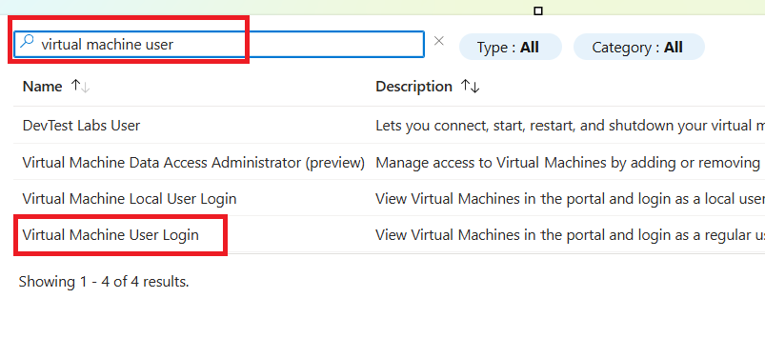
Click on Select members and then add your virtual desktop users security group inside and then review + assign.
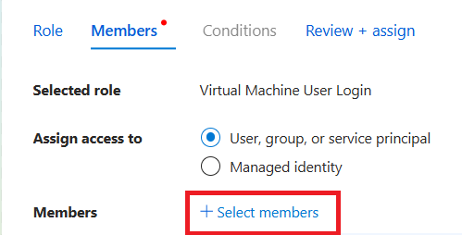
Repeat the same steps except this time add virtual machine administrator login role assignment > add the virtual desktop admin security group created earlier as member for this role assignment.
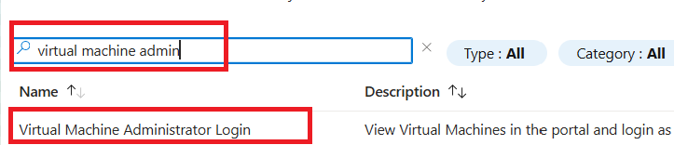
Now go back to your Azure virtual desktop > host pool > RDP Properties > Select connections will use Entra ID then click on save
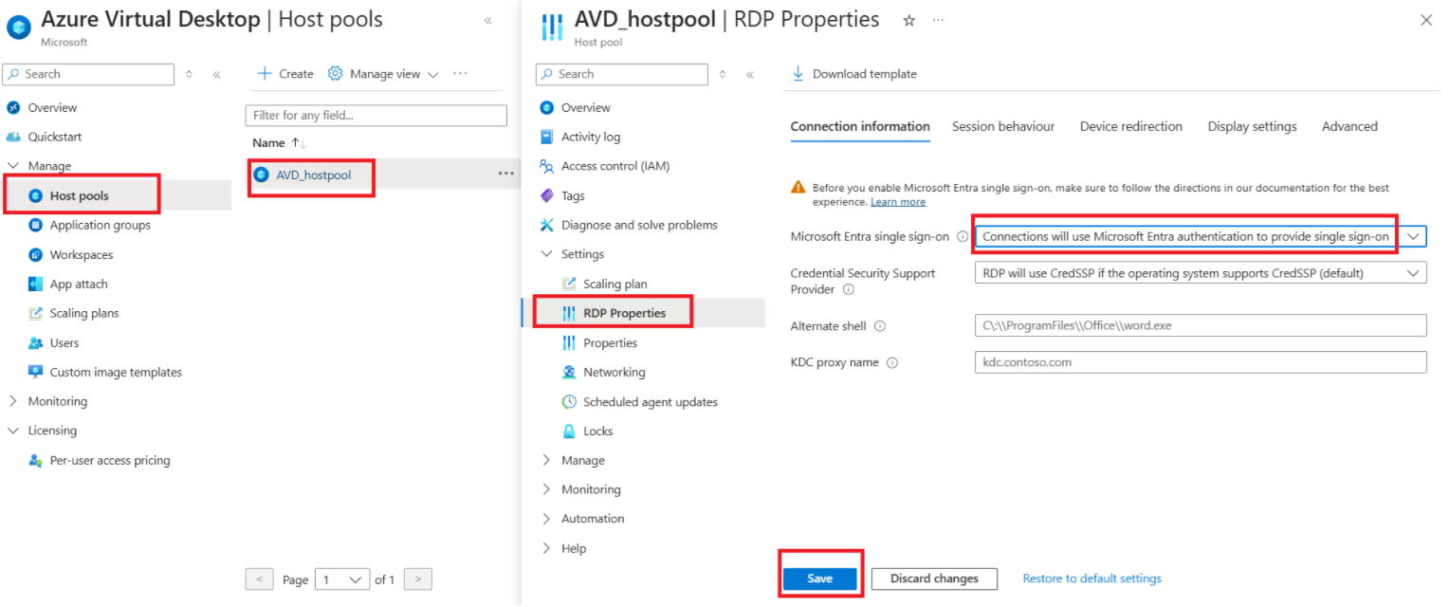

Now let’s test login to our virtual desktop. Open a web browser and access https://rdweb.wvd.microsoft.com/arm/webclient
You can login with the account you created in M365 admin center for virtual desktop user
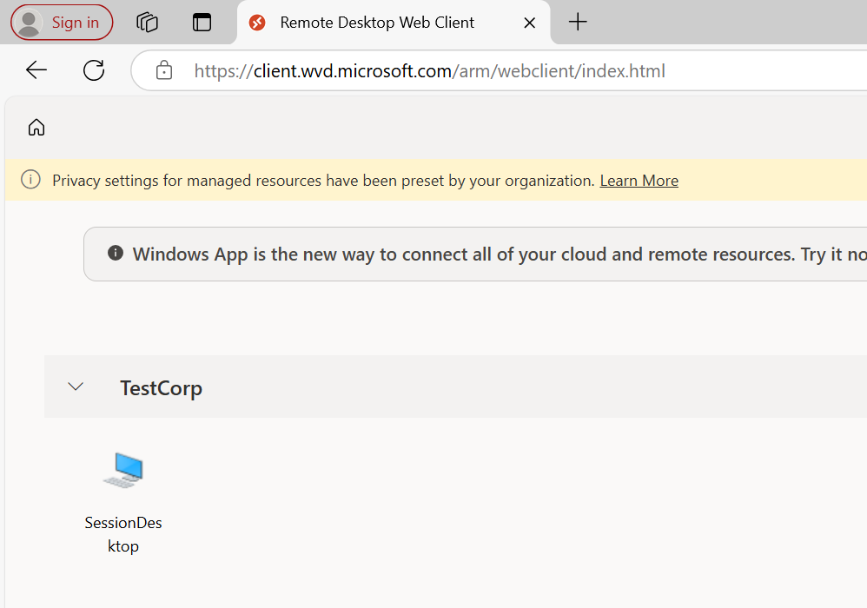
Click on the session desktop and allow
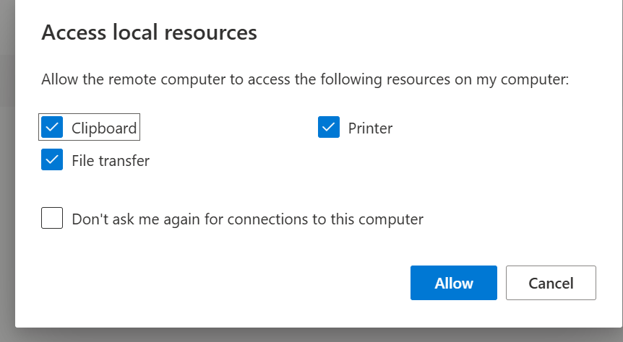

Now you are able to access it from your web browser!
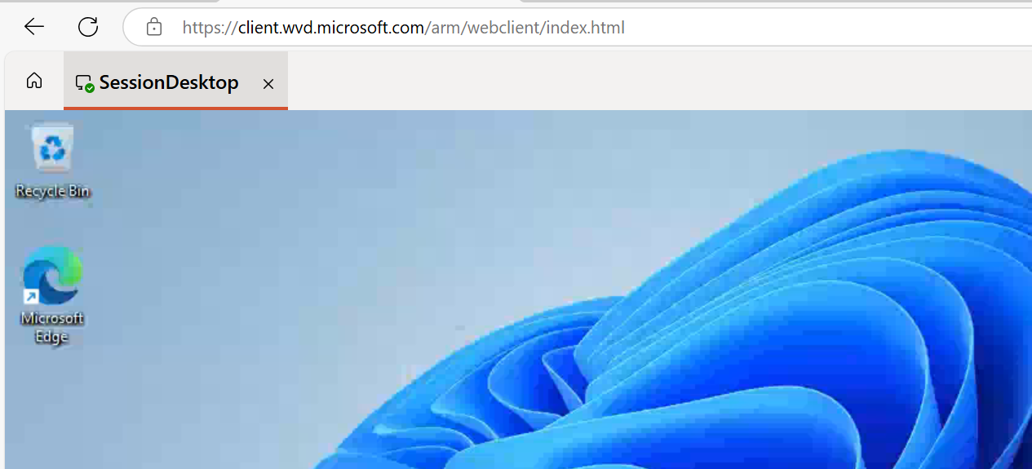

There is a separate guide to configure scaling and auto startup/shutdown during business hours for Azure virtual desktops.

